# 

# TECHVOLUTION: A NEW PHILOSOPHY

by Johnny Majic

March 2019

## Backpage

Are you happy? I don’t mean doing okay, content, or “happy enough”. Do you love starting your day, are you respected at your job, do you feel the joy of good health, and perhaps the biggest question; how confident are you that your kids will have a better life?

On the surface, Westerners have luxurious homes, full employment, and stable politics. On the inside, our middle-class deals with boring jobs, growing debts, stagnate wages, drug epidemics, crumbling infrastructure, antisocial behavior, political hatred, climate change—all good reasons for unhappy lives. We have the freedom to vote Left-wing or Right-wing, moderate or extreme, and we’ve tried them all, but none have made Main Street—all of us—happy with our society.

Living happy lives isn’t an unrealistic fairytale. In fact, it’s a sign of a healthy society. What’s standing in our way is Left and Right political ideologies. They were created in the Industrial Age, and since 1970 we’ve been in the Internet Age. Our ideologies are so outdated they’re causing our frustrating lifestyles and growing social unrest. We need a new philosophy, one designed to harness the remarkable potential of apps, computers, and the internet.

Here it is. Its big lesson is this. The middle-class needs to step up and use modern digital technology to solve our own problems now. If we don’t, we’ll soon be suffering something much worse than unhappiness. There’s only so long we can keep running our civilization on old—ideological—fumes.

## Table of Contents

1. Introduction
2. Prologue
3. Act One - The Beginning
4. Act Two - Blowing Up the Death Star
5. Mid Point - A Techvolution Battle
6. Act Three - Climax
7. Epilogue
8. The Appendices

## Dedication

*This book is for the people in the open-source community. For the collaboration philosophy, you handed down to me. For selflessly updating Wikipedia, writing free software, and building cool new tech for us all. For being the protagonists of the Internet Age. You gave the best education a political guy can get. I hope I’ve learned enough to write this book for you.*

*For the antagonists, the self-entitled delegators keeping Blockbuster—and it’s Industrial Age mentality—alive, thanks for causing history to repeat itself yet again. I hope you learn something.*

*This book is especially dedicated to the extras on Main Street. Because when it’s time for you to act, I pray you decide to play the game.*

## Quote

“*We are really the revolutionaries in the world today—not the kids with long hair and beards who were wrecking the schools a few years ago.*”

Gordon Moore, co-founder of Intel, 1973.

## Note to the reader

I used many images and videos throughout the book. They help explain ideas, so why not. I especially did so, to showcase how life-changing the internet is. Today, millions of regular people are communicating views, opinions, and information with no middle-men to control their messages. Not since the printing-press has information empowered ordinary people so much. While I very much want to help creators and their audiences realize how historic their work is, of course, all credit for the media goes to them.

Also, I use Star Wars, Star Trek, Harry Potter, and other popular stories. If you’re not a fan, don’t worry too much. If we were in Ancient Greece, I’d use Greek Mythology. If we were in Victorian Britain, I’d use Shakespeare. Using familiar stories is a more natural way to explain philosophy, politics, and to relate to one another. Of course, all due credit goes to the media’s owners.

# Introduction

## Politics

Donald Trump is the savior of Western Civilization. If that turns your emotions on, with tears or cheers, then you are missing the point of politics. Politics isn’t voting for a political party, advocating for a political cause, and it’s definitely not screaming at a TV. Doing all these things may change the world. But the government is so big—with so many politicians, civil servants, companies, and interest groups fighting for control, it will never respond to your small voice. Tears or cheers don’t make a person powerful.

Deciding how to live your life does. Because exercising, composting, teaching your kids mathematics does change the world. Good decisions change and improve your world—giving you freedom from dependency and power over your part of society. And, since power is to politics what money is to finance, your personal choices are always your most powerful political weapon.

The question is, how do we increase your powers. The answer, we’ll find out in this book, is better technology, and the self-awareness to use it to improve your life. But this isn’t a self-help book about making you “happy.” It’s about making you powerful so you can earn your happiness.

Our civilization needs your happiness. Our way of life is trying to evolve into the Internet Age. But, the established powers of the Industrial Age is holding us back. Our civilization is offering the middle-class a good deal. If we grab hold of modern tools and join the fight to upgrade our society, we live happy lives again.

## New Tech, New Age, New Philosophy

Life improves with better technology. Deaths from disease, famine, and war have all gone down as our technological power has gone up. While naysayers love to spread depressing news about our world today, human progress justifies much optimism about our future. Plagues used to wipe out 30-80% of our population. Famines were once a fact of life. It wasn’t long ago that reading and writing were only for the rich. For crying out loud, the month of March is named after “marching” to war because our ancestors did it so often. We have many problems today, but our technology in medicine, agriculture, education has given us lives our ancestors would call a fairytale.

Now we have computers and the internet. They are game-changers. Laptops, digital cameras, tablets, drones, digital sensors are all millions of times better than just 30 years ago. Modern technology dramatically empowers us to keep fighting off pandemics, hunger, ignorance, and war. But, only if we use them to keep inventing and staying ahead of our problems.

In Nature, lifeforms evolve in jumps called eras or epochs. Likewise, humanity develops new technology in leaps; what we call “ages.” When a new age comes, its technology is so unique and powerful, it changes how society functions. Things were very different in the Stone Age in comparison to the Bronze Age, for example.

Today we’re going from the Industrial Age (1760-1969) to the Internet Age (1970-). It can be hard to appreciate all the changes. There’s a lot to think about when civilization’s entire way of life upgrades to new technology. I’ve been thinking about our evolution for years and only now have a grasp.

Improving our technology is hard work, but at least we understand how to do research and development. Improving politics isn’t so straightforward. Upgrading politics and philosophy happens with strong emotions, civil wars, and revolutions. I want to help you understand your importance in our political evolution. Because in 1970, personal computers and the internet came online. Since then, computer geeks, hackers, and innovators have been upgrading our society to the Internet Age. All the while, Industrial Age companies, and bureaucracies have been holding us back to keep their obsolete products and services alive.

Being forced to use outdated technology is why middle-class life can be so unhappy. It’s why we drive in endless traffic, still us so much oil for our energy, can’t understand the tax code, and worry about our kids’ futures. Middle-class life will only get better once we finish the Internet Age upgrade. There’s no shortcuts, cheats, or gimmicks. There’s just you and your friends on Main Street who have to do the work.

This book integrates lessons from the history, politics, and philosophy of prior upgrades, but it’s not written for any buff. It uses the power of stories to help the middle-class see their duty to change the world. The first step is a new mindset. Because we the people already have the amazingly powerful digital tools we need. We only need to believe in modern philosophy to upgrade to the Internet Age.

## Looking Up

There’s a lot to realize when thinking about human evolution. I found it very helpful to “look up” and imagine what our community looks like from above. Looking up lets you “look down” gain a proper perspective on our society.

I didn’t just imagine a better perspective; I got to see it. Play computer games like *Age of Empires, Anno 1800*, and *Civilization*, and you’ll get to as well. You’ll be the “player god” of a civilization. A virtual divinity who knows all and sees all, and who puts its general will into action using an array of buttons, switches, and toggles. As you play the game, you’ll use these levers of power to decide what to research, where to place buildings, and, most notable, when to click “upgrade” to a new age. Pressing that most important button magically transforms, every factory, hospital, road, house, citizen, to the technology of the modern era. Below, you’ll see a person being the player god in the game *Anno 1800*.

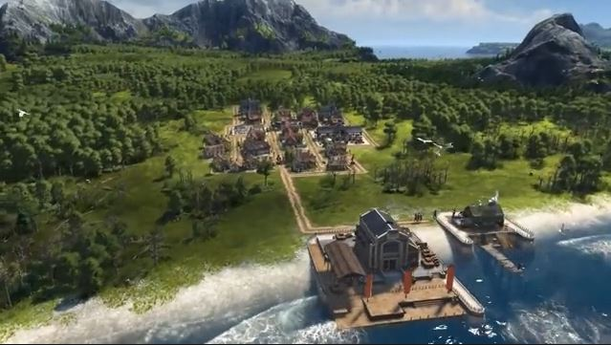

The above is a computer game, of course, but it represents reality pretty well. We’re all in there somewhere right now, trying to figure out how to earn a living while the game plays around us.

That’s why this book’s cover page is a regular person standing on Main Street—a single guy or girl in civilization. His or her job is to do what’s best for themselves, and help society prosper. Gazing up for guidance, the person sees two options; heroes and villains. In the sky high above is the mythical “player god,” whose ultimately the one making the decisions. Will the player god act to benefit society or to benefit himself?

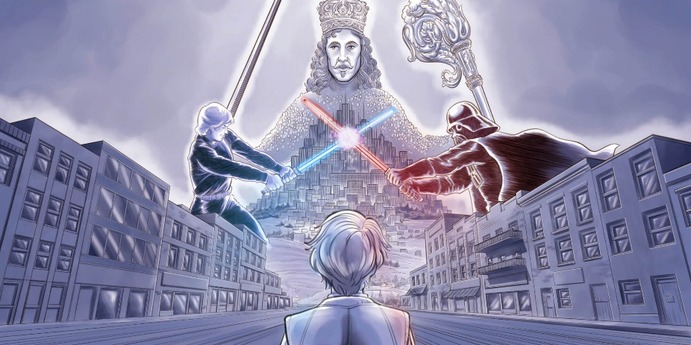

In a computer game, the player god controls all levers of power. In reality, we change society when we buy clothes, do car maintenance, and save up for a new home. Funny to think about, but our everyday choices determine what happens in our entire civilization. Yet we often don’t think of ourselves as being “player gods.” But that’s the big picture, isn’t it? That it’s all our individual choices that make up the player god in our real-life game of civilization.

The more individuals realize the big picture and act like their actions matter, the healthier their society. And the job of inspiring individuals to believe in the big picture is the work of philosophy.

So, what the heck is good political decisions today? Who are the good guys? Every newspaper, politician, and political party says they’re fighting for the good of our society. But our politics have so much disagreement, how can a regular person know the difference between heroes and villains?

You should feel empty right now; open-minded, unsure how to act. Because we’re all Main Street today, looking up, trying to figure if Donald Trump is evil, or if the United Nations is trying to make a world government. We ask if Fox News is manufacturing fake news, or maybe “all of them” are. If so, what’s real news? The questions never stop. Should the government-run health insurance, or a big corporation regulated by the government? Is climate change real? If so, why do our “green” obsessed offices force us to drive to work every day?

It’s all very confusing and emotional. Yet you have to pick an answer. After all, you’re part of the player god as much as anyone else. Wouldn’t it be cool if a philosophy showed you the difference between good and bad politics today? It is cool; it’s calming to understand politics, it’s one reason why I wrote this book. So I, and whoever reads it, can better understand our place in the never-ending game of civilization. But, I mainly wrote this book to create a new philosophy. One that will get Main Street to reach for their society’s new digital levers of power. Only then will we finally enjoy the greater productivity, dignity, freedom, and happiness of the glorious Internet Age.

## Your Politics Is Hard to See Because You Are Changing

We create philosophies to organize civilization. Philosophy’s high ideals of a “just and good society” get everyone literally on the same page. There are always plenty of theories to choose from. The player god must pick one that empowers everyone to use modern technology to solve real-life problems, and hence give their society a happy life.

When a player in Anno 1800 upgrades technology, we can see the changes. Installing a sewer, damning a river, building a road, is very obvious. But we can’t see philosophy change so easily; because it’s our minds that evolve.

For example, we all believe in a philosophy of “Life, liberty, and the pursuit of happiness.” But what does that mean in everyday life? Giving people political guidelines is why we invented ideologies. Conservative or Progressive. Libertarian or Socialist. Republican or Democrat. Eaches doctrine supports “Life, liberty, and the pursuit of happiness.” Ideologies go in detail by while giving their believers a list of specific policies to fight for (or against) like universal health-care, gun-rights, or strict environmental regulations.

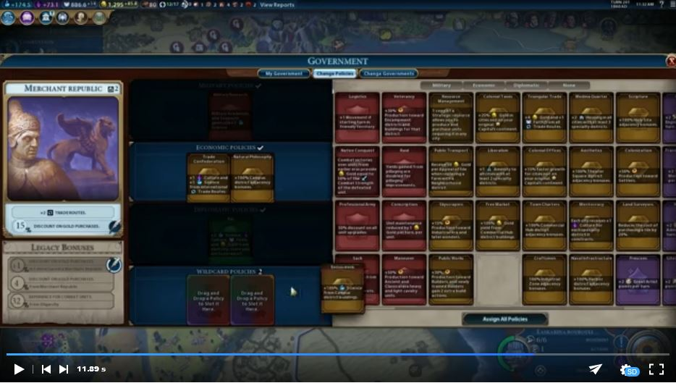

That’s a “tech tree” of new technologies, tools, and philosophy upgrades. All games use them to give the player the choice of which to use in their game. Just like improving our technology, we also upgrade our philosophy with a simple “click.” It’s just so damn hard to see philosophy change because it’s our minds that are evolving.

The point is, even with ideologies to guide our philosophical opinions, understanding our political views is still hard. We all look up at the same doctrines—we all try to “think of the big picture,” yet we arrive at different answers. Our opinions are a by-product of our psychology, job, skillset, family, geography, culture, ethnicity, religion, time-period. Who can understand how all these factors intermix to make a political opinion? Why does one parent cry tears of sadness, the other of joy, on the same election night?

I can’t explain it either. But I can help you understand politics today. We live inside the game of civilization, and inside this game, we develop in ages. At the dawn of a new age, a wealthy establishment always fights idealistic inventors to determine which philosophy will click with the people and therefore be the ruling philosophy of society. The establishment uses the rules of the old philosophy to persuade, or force, the people to keep the rich in power. At the same time, inventors distribute new technology to lure people away from the past. Here is when everyone on Main Street makes a big choice.

Does the regular person help the protagonists evolve civilization by reaching for modern tools, or help the antagonists hold back progress by following old rules? If you stay out of the fight, you support the establishment, keep things the way they are, and are thus an extra watching the story of civilization. If you decide to grab hold of the new levers of power and upgrade society, you’re a player god, playing the game of civilization.

We hit the Internet Age in 1970. Since then, hackers, geniuses, and geeks have been fighting to give the incredible power of computers to Main Street. The people who control Industrial Age technology are fighting them off with things like copyright laws, non-disclosure agreements, and political lobbying. And the people on Main Street have a choice; do they step up to help the heroes?

That’s a choice you, the person reading this right now, has to make. It’s a choice as big as any you’re ever going to make. Because if we don’t upgrade now, it only means your kids and your grandkids will live even unhappier lives. The burden of transforming society will only fall on their shoulders.

A bit heavy to pull on your parental heartstrings, but it’s true. Life on Main Street will keep getting worse until we upgrade to the Internet Age. Evil things like debt, depression, disease, and war only stay away if we keep evolving our technology and philosophy. Don’t worry. We can finish the Internet Age upgrade. The people only need to believe in a new philosophy that turns us all into player gods. My job is to make it click.

## We Upgrade our Politics Now, or We Lose the Game

Politics is quite emotional today. From the disputed elections of the American government to the radicalization of European politics, I think it’s fair to say Westerners fucking hate each other; and many don’t know why. They’re just angry. And not in the “I stepped in the puddle” sort of way. Mad in the supervillain whose plans for world domination are going up in smoke “because the other side is ruining everything!” kind of way.

Let’s get some perspective. Today, regular people are increasingly unhappy. We pick an ideology to help us. Conservatism and Progressivism are the big choices because both spanned the world on the back of the Industrial Age and the era of mass-production. Conservatives fight for free-markets to help society create more property, Progressives fight for property redistribution to keep our community fair. This divide causes a tug of war over regulations, tax rates, subsidies, and other government policies.

However, digital property can’t be mass-produced or redistributed. Digital books, paperwork, audio, and video is automatically both. As our world becomes more virtual in the Internet Age, Industrial Age mentalities grow obsolete.

But rather than rethink hundreds of years of “Left vs. Right” politics, both sides turn extremist. Old-school businessmen keep their Conservative troops loyal with constant stories of “fighting evil communists who are coming for your money!.” De-regulation, tax-cuts, free-trade are among the more popular right-wing rallying calls. In contrast, social justice warriors keep left-wing politics exciting by “fighting racist fascists who want to oppress you!.” Their choir forms around demands for justice, regulation, and the redistribution of wealth.

Fascism and communism (thankfully) died decades ago. Meaning few people in Western societies call *themselves* fascist or communist. Left and Right call out names because neither understands digital technology helps our nation prosper—as Progressives dream—by forcing us to better ourselves—as Conservatives demand. Instead of opening their minds, Left and Right leaders label their enemies Nazi bigots and crazy communists. They want to keep their believers in the choir singing against “the other side.” Fighting phantoms distract the people with great television.

Spectacular entertainment is their plan. Left and Right don’t want regular people to become player gods of the Internet Age. They want their supporters to stay extras in the Industrial Age. Neither Right or Left will hold onto their power when our society upgrades our politics to modern times. When Main Street asks why their commutes are so long, home payments so high, managers so many, Left and Right ramp up their spectacle. CNN, Fox News, MSNBC, and the rest put up “Breaking News! The Other Side Is Ruining Our Country!” to distract their believers for a little while longer. Blockbuster sequels and remakes do the same thing when they jack up special effects because their stories suck.

[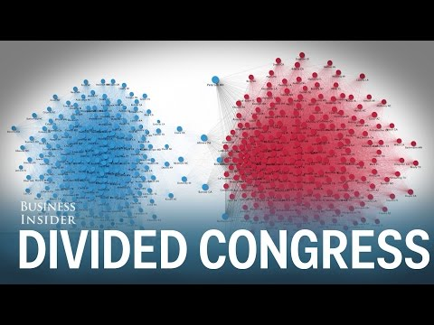](https://www.youtube.com/embed/tEczkhfLwqM?feature=oembed)

1In the Industrial Age, Left and Right used to cooperate all the time. Not anymore. This video excellently shows the growing hatred between them. It’s about the US Congress but applies in every Western country. Notice how the divide started in the 1970....

The answer to hateful ideologies is to upgrade our philosophy. Sadly, in history, upgrading only happens when old doctrines kill each other off. The Thirty Years War (1618-1648) is an all too good example. Fought during the Science Age between the kingdoms of Europe, when powerful nobility still justified their rule using the Medieval Age Christian philosophy of “nobles divine right to rule.”

When Main Street demanded a better life, the ruling philosophy only had two branches of Christianity; Catholicism and Protestantism. Regular people had to pick a team and slaughtered “the other side” on behalf of supposed holy kings. One author summarized The Thirty Years War as “a warning of the dangers of entrusting power to those who feel summoned by God to war, or feel that their sense of justice and order is the only one valid.”

The Thirty Years War was extremely brutal. One in five Europeans died from it. The carnage only stopped when both sides were exhausted. The worst part was when the horror ended, the people realized they were no better off—and what they were sick of were kings and nobles. So, philosophers wrote a new philosophy of Democracy. Thus, it wasn’t long until ordinary people finally upgraded to a new ruling philosophy. As player gods, they fought against Divine Kings in the American Revolution (1776), the French Revolution (1789), and many more afterward.

The hatred between Catholics and Protestants should sound scarily similar to the relationship between Left and Right ideologies today. Today’s hateful fights over presidential impeachments, border walls, and trigger words are a smokescreen. Neither Right or Left can see or admit; they’re both behind the times in our modern age.

## The Internet Age Needs a New Philosophy

For our society to see the big picture again, we need a new philosophy. One that looks ahead towards the boundless horizon of the Internet Age. One that considers the work of protagonists like Tesla, SpaceX, Blue Origin, as a sneak peek for the wondrous future each person should be building now, bit by bit.

I’ve studied this topic for years. Academically, at the University of Toronto, I worked on political philosophy, history, and innovation. But I learned far more on the frontline as a projectionist, line worker, an account manager, claims adjuster, and especially making a digital tool for an Industrial Age industry. I wrote this book to my fellow people on Main Street today; here’s how we fix our problems and win the game.

You’ll like it best if you’re sick of contemporary politics but love checking-out what Elon is up to. Because you’ll understand most of today’s problems are—with digital technology—quite simple engineering problems. We don’t have to invent impossible technology like time-travel to solve road traffic, rising health insurance costs, or personal loneliness. You’ll really like this book if you know that unless we see ourselves in the video below, evolution will find someone who does.

[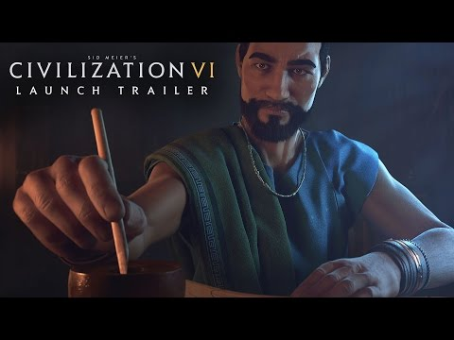](https://www.youtube.com/embed/5KdE0p2joJw?feature=oembed)

That’s our ancestors in the video, and it should be all of us today too. So, if you hate technology, despise your job, see conspiracies everywhere, worry about climate change, are intimidated by the uber-rich… fine, you’ve spotted a problem. But now what? Whatever problem you have today, modern technology empowers you can make a difference today; right now.

I wrote this book to get you dreaming again. It’s written to be like *New Atlantis*, *On Social Contract*, and *Common Sense*. All books that helped start modern democracies. They made unhappy people on Main Street realize the big picture—our choices are our most potent political weapon. Advanced technology makes our choices into arms of change. But only when we believe in a new philosophy will we be player gods holding the levers of power in a modern age.

Today, if we don’t step up to upgrade our society, we’ll keep suffering the unknowns of a degenerating society. We’ll stay unhappy extras watching stories of phantom communists and fascists, instead of gazing up to a future as player gods in the stars.

And if we stay extras, at least with this book, our kids can read what their parents could have done as they regret the choices of player gods who lost because they refused to play the game.

## Here’s the Grand Mission of Techvolution

Writer David Mamet once said being free from trying to please a group means being open to see Nature. So I embraced being a regular guy and was quite ambitious when writing this book. Saying that Techvolution has three parts:

**I. A New Philosophy**: This part upgrades our philosophy to the Internet Age. It gets Main Street to see the big picture; that we’re all player gods who must use apps, electronics, and the internet to solve our problems. Main Street has to learn, it’s good to be selfish; because living happy lives upgrades our civilization.

**II. Building the Life Star**: Explains the new political and economic truth we’ll see in the Internet Age with technologies like apps, bio-monitors, and big data. With these digital tools, we’ll be able to create objective definitions of political and economic right and wrong. In short, the Life Star will do for politics and economics what scientific instruments did for physics, chemistry, biology, etc. The troubling part is many people—especially phantom storytellers of old philosophies—won’t accept what this new telescope shows us.

**III. Starting Starfleet**: We’ll design digital tools detached from the Industrial Age. As the Industrial Age’s material abundance helped us live in so-called “perpetual peace,” Internet Age products will make our lifestyle one of “perpetual profit.” We’ll send the massive savings to Musk and his protegees and hence jumpstart the Space Exploration Age—or as I like to say, “Start Starfleet.”

**How to See the Matrix**: To write Techvolution I mixed Aristotle’s Poetics, to better understand Hegelian dialectics, and then I added some evolutionary biology. If that bores you to pieces, that’s cool, you don’t need to read more about it. But just so you know, Techvolution is based on a full-blown philosophy that I’ll explain in another book called *How to See the Matrix*.

===

Techvolution A New Philosophy has a very high goal. So, I want to be crystal clear about its purpose. We’re in the new and wondrous Internet Age. But we’re still using the philosophy of the Industrial Age to run our society. Conservatism (1791), and Progressivism (1859) philosophy cards were clicked many years ago. It’s thus no longer good enough for Main Street to watch infotainment news, donate to a social cause, march in a demonstration. We can’t assume our political system will solve our civilization’s problems.

To improve our world, we need a new ruling philosophy. One built on the accomplishments of our past, but that factors in the wondrous possibilities of digital technology. Our new way of thinking must unite Main Street to again see the big picture; that we’re all player gods whose choices determine the health of our society. We must still vote and debate what’s best for our community. But reaching for the Internet Age levers of power is our most potent political power. We, the people on Main Street, can change the world ourselves.

With great power comes great responsibility—that’s why the duty to solve our growing problems also requires the freedom to choose any tool we want.

Tools can be anything: a thermal camera to spot leaky windows, the Waze app to lessen gridlock, or 3D printing a tool to sell to a neighbor. The desire to seek out new tools is human evolution. Civilization evolves when its members read a modern philosophy telling them to become a player god of the modern age. We’ve upgraded our philosophy many times before. This book is the best way I know how to do it for our society today. I hope it’s good enough to click.

[](https://www.youtube.com/embed/oOOOfZWXPu4?start=8&feature=oembed)

*These guys run a popular YouTube channel about computer hardware. They didn’t like how YouTube changed and decided to make a new video service called Floatplane. They thus became Internet Age protagonists. This is real politics. Because it promotes evolution. It doesn’t matter if Floatplane thrives or dies. We, as individuals, can only try new ideas and see what works. Marching against climate change, or watching infotainment television is merely being an extra. The struggle with our society is regular people don’t think to act like protagonists or player gods. And even worse, it’s often against the rules to because Industrial Age companies want us to keep using their obsolete products. We’ll overcome these antagonists below.*

===

# Prologue

## Fighting For The Internet Age - Our Philosophy is Already Generations Behind Our Technology

The Internet Age seeded itself a long time ago. Starting way back in 1843, inventors like Ada Lovelace, Vannevar Bush, and Alan Turing were building the first experimental computers, beautifully clunky machines that filled rooms. At the same time, writers like H.G. Wells, Isaac Asimov, and Gene Roddenberry imagined what life would be like once the Industrial Age ended and advanced computers ruled the world.

These authors’ stories, such as *War of the Worlds*, *I, Robot*, and *Star Trek* thought of a future so hard to grasp people called it science fiction. Then came the 1970s; when personal computers, microprocessors, the internet, and other digital technology became real products anyone could buy. Here started the Internet Age—and it transformed the world just as much as science fiction said it would.

With every purchase, renovation, and Christmas gift since 1970, we’ve been filling our society with fundamentally different technology. It’s easy to under-appreciate how just one of our laptops can be so many machines: a typewriter, radio, recorder, book, television, photo album, database, calculator. In contrast, mechanical tools of the Industrial Age are single-use, can’t be easily shared, and need many workers and managers to work.

Corporations populated the world with mechanical products during the Industrial Age. They put in colossal production lines and supply chains that spread across the globe to maximize how much stuff we could make. This era of mass-production was so competitive that only a few companies could survive. If you’ve ever watched CNBC’s, you’ve seen their desire for ever more sales and profits. Businesses must compete ever hard to stay alive in the era of mass-production.

Digital devices enable a new philosophy, one that fosters not a competition, but collaboration. Using computers and the internet for online collaboration is our future because it saves us from the redundant work of mechanical tools. For example, with Wikipedia, the world can use one website for its general knowledge, instead of reprinting, shipping, and buying millions of encyclopedia books every year.

Now, several generations into the Internet Age, items like smartphones, laptops, and smartwatches are everywhere. That’s why the collaboration websites like WikiHow, Facebook, and YouTube integrate so easily into our lives. It takes just a few minutes to learn the basics of these tools, and we’re communicating with the world! Collaboration is today’s big picture, the basic principle of the Internet Age’s new philosophy. The people who understand this best are the open-source community.

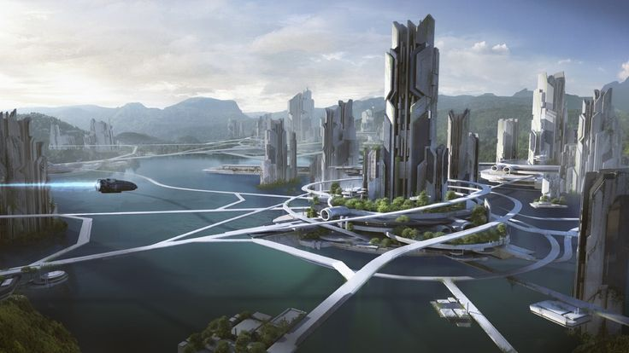

*The land of perpetual profit. We’re never going to get there with Left/Right politics.*

## Open-Source Protagonists Are Pushing Us Into the Internet Age

Open-source is a growing community of inventors, designers, and programmers. They are the successors of the first computer protagonists. With honest hearts and genius minds, they’re leading us all into the Internet Age. They live, breath, and promote collaboration at places like GitHub, Wikipedia, Dribbble, Udemy, Stack Overflow, Unsplash, and Slack.

These modern-day Jedi have given Main Street the levers of power we need to control the Internet Age, even if we the people don’t realize it yet. Most of us still think things like retail stores, manufacturing, and education are industries only for governments or big businesses to control. However, because of the open-source community, there are countless new tools for average people to take control of their work, identities, and lives. It’s like Cinderella can stop praying her fairy godmother gets her past the palace gates because open-source has given everyone an invitation to the party.

Open-source heroes live to democratize technology. Every day they find new ways to distribute more levers of power to the people, letting us all share in our society’s economic prosperity. Look around. Note the parents who are educating their kids on Khan Academy. The moms learning how to repair iPads thanks to YouTube videos. The artists selling their products on Shopify websites. By distributing society’s levers of power, open-source has turned—or threatens to turn—many Industrial Age companies, products, and professionals into needless middlemen.

The open-source community has super-charged Main Street. No longer are we bound to be extras in the Industrial Age, hoping for a better life. Now we can become player gods in the Internet Age, making a better life.

I’m one of them. I’m a politics, history, and philosophy geek who spends far too much time thinking about this stuff. Digital tools let me write, research, host my work. I can very easily find world-class writers and illustrators to add a professional touch. Heck, think of the connection between you and I. You’re reading my ideas with no middlemen and for virtually free. All because open-source heroes put the power of new tools in both our hands.

The open-source community calls this disruption. While disruption has thankfully torn down many gates, it mainly replaced low-hanging fruit like consumer goods. To keep pushing us into the Internet Age, we need to upgrade disruption with Techvolution. Only a society full of power-hungry player gods will finally turn the fantastic world of science fiction into Main Street’s new reality.

## Mass-Production Replaced by Mass-Collaboration Makes Us Happy

As a kid, I helped my family clean office buildings. My simple role was to pick up the garbage and blue bins. Other than the still hating the smell of old coffee, I really appreciate getting to learn honest work. Years later, when working at a big office, the cleaners were short-staffed for a few weeks. Management spent hours meeting about and discussing the “garbage problem” instead of just wrapping it up (pun intended) and moving on.

The Industrial Age started when the steam engine powered the world’s first production lines of wheels, lathes, drills, and presses. Even with mechanical power, mass-producing trains, clothes, and newspapers needed a lot of manpower, which thus required a lot of managers. Look below, and you’ll see a typical production line our ancestors worked.

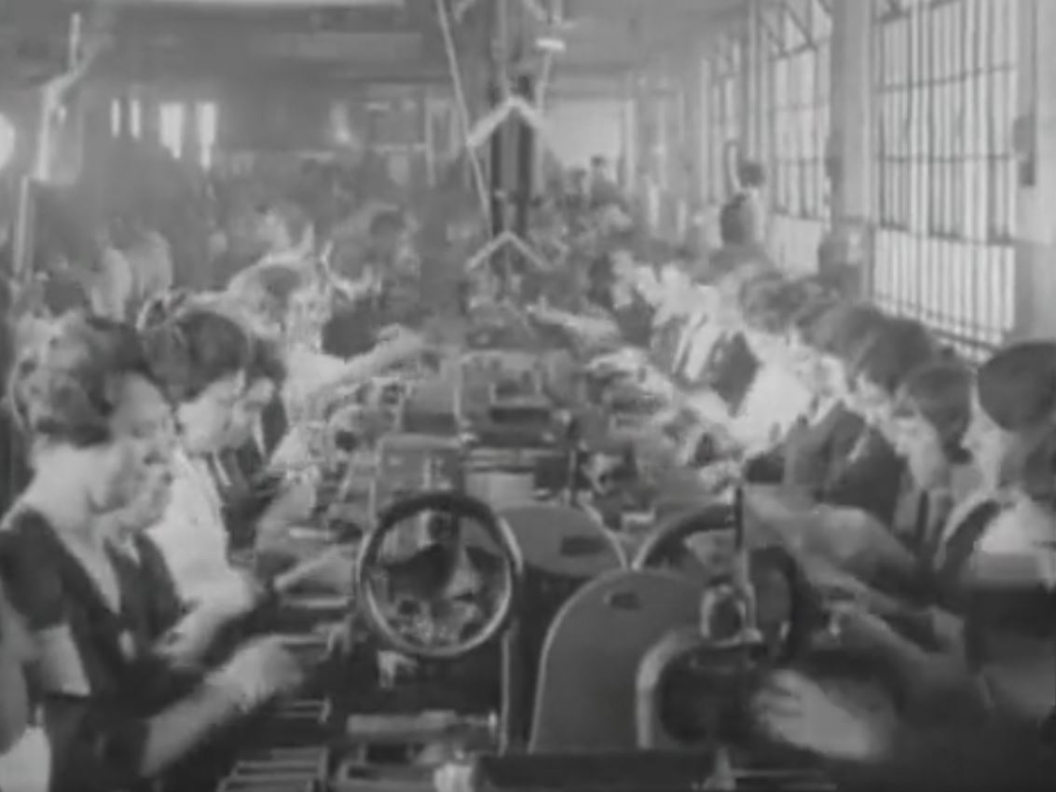

Today we don’t work on the assembly line with bulky steam engines or massive presses. Much of industrial production is automated (or, sadly, outsourced). Most Westerners right now work in hospitals, construction sites, or in an office. And it’s time for these workplaces to transform the same way the manufacturing has. We do it by empowering workers and customers to collaborate directly. Just as the Industrial Age had mass-production, the Internet Age has what I call mass-collaboration.

Main Street is already starting to collaborate. Millions ask questions on Quora or look up how-to videos on YouTube. Google only searches for the answers real-people have made on their own websites. What stands in the way of mass-collaboration at work is excessive management, an unneeded holdover from the Industrial Age. It’s only out of habit that our workplaces still over-value control and delegation instead of contribution and collaboration. Discussing “garbage problems” inside endless meetings gives many managers something to do now that computers and robotics revolutionized old production lines.

A culture of micro-management by layers of management is rotting our economy. It turns leaders into gatekeepers who get rewarded for keeping society using Industrial Age technology. Today there’s an entire class of consultants, administrators, managers, and executives who don’t know the skills of their industry like nursing, teaching, and (definitely not) cleaning. Their power is to be middlemen keeping the people gated behind an Industrial Age technology like broadcast television, newspapers, or call-centers.

This desire to keep things the same creates much antagonism. Because we all have tools like computers and an internet connection, we need to coordinate with each other directly. This new way of thinking is sometimes called “Wikinomics.” With hundreds of thousands of active projects, open-source shows us how easy and effective mass-collaboration is. The open-source community works by coming together to make a core technology. Groups then use the core technology to create specialized products.

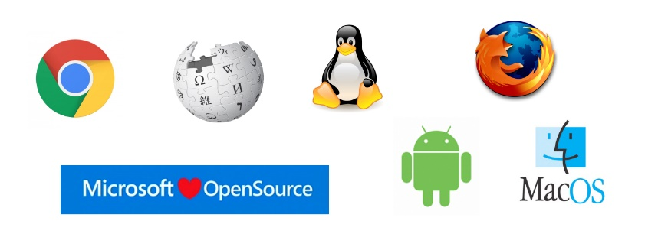

*Some of the more famous open-source projects. Most of this software, worth many hundreds of billions, you can download and use for free. If you can’t program, it only takes hiring a few to get whatever product you can imagine.*

For example, a large open-source community creates MediaWiki software. Then separate groups use MediaWiki to create Wikipedia, WikiHow, Fandom, and any other website you can think of. After all, MediaWiki is free for anyone to use however they want; gatekeepers be damned! More than just programmers, mass-collaboration is how the Wikipedia community of writers, researchers, and editors wrote millions of articles in only a few years. It’s also how Linux, Android, Chrome, and many other excellent services work too.

All this praise doesn’t mean open-source communities are perfect and can run the world. Open-source is only a part of the ecosystem bringing the Internet Age and mass-collaboration to life. There will always be big companies like Duke Energy, Ford, and Boeing with large corporate structures, mass-producing our essential products. Likewise, the government will still run social programs and install traffic lights.

That said, open-source is vital.

Precisely because nobody owns its technology, server software, operating systems, web apps, and so many other remarkable technologies are free to use. That means Industrial Age gatekeepers can’t stop digital inventors from empowering more player gods, whether it’s with a simple rotating list of persons to take out the trash. An online encyclopedia with millions of helpful articles. Or software to give society internet streaming—as when a few hackers tore down “Darth Blockbuster’s” gate when he tried to keep us buying and borrowing his DVDs.

To continue opening gates, building the era of mass-collaboration, and pushing us into the Internet Age, the open-source needs our support. We can’t ask any more of them. The Jedi have done their job. Main Street needs to step up and flock to their banner and grab hold of the levers of power they’ve made for us. We will, once we become player gods.

[I had the privilege of serving as a lead creative, design and animation working on Figma's first-ever video explaining what the amazing product is.

CREDITS
Client: Figma
Directed by Enle Li
Art Direction & Illustration: Enle Li
Animation: Enle Li, Jaedoo Lee, Seongjin Yoon
Music & Sound Design: Playdate](https://player.vimeo.com/video/366560857?app_id=122963)

*Figma is a design tool for websites and apps. In the past, designers, writers, programmers all spoke through many managers. With Figma, worker-to-worker collaboration becomes super-easy. Your workplace can, and will, one-day foster cooperation like this. And it’s the open-source mentality that lets us build it for ourselves.*

## Fighting for The Future - The Era of Mass-Collaboration Won’t Just Happen

Once upon a time, I only wanted to learn about the open-source fight. Now I want to push it forward. Mass-collaboration, telecommuting, the right to repair, home power generation, and real internet privacy are just the tip of the iceberg. The visions of science fiction will only be a reality once we replace old Industrial Age tools. The open-source community must get political, get mad, and learn to be selfish because they’re the leaders in the age-old story about New versus Old. Protagonists versus Antagonists. Jedi versus Sith.

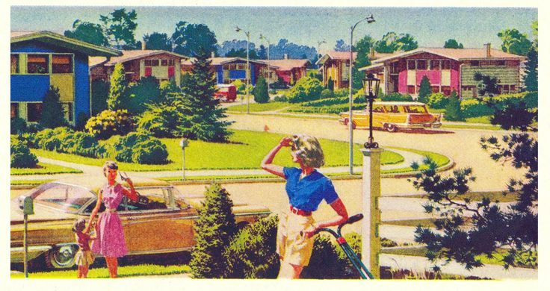

*The American Dream, if you want to live in 1969 forever. There are lots of antagonists in this photo. Newspapers, broadcasters, oil, gas cars, k-university education, are among today’s largest Industrial Age holdovers.*

The most dangerous thing right now is ignorance. People don’t know about open-source or the future they’re fighting for. The people are stuck fighting phantoms on behalf of outdated Left vs. Right politics. Both sides idolize 1969 because that was the end of the Industrial Age, and hence when they both peaked. Leftists think public life is one long Woodstock “activism” festival. At the same time, rightists really feel the perfect *Leave it to Beaver* suburbs will return once “the socialists” are defeated. Our civilization needs Main Street to stop chasing ideological phantoms.

To do it, Main Street has to believe in a new philosophy. One that gives the levers of power to bakers and butchers over factory food owners. Tailors and sewists over sweatshops. Medics and nurses over hospital administrators. Engineers and designers over executive bean-counters. Store owners and clerks over franchises. We’ll finally upgrade our civilization to the Internet Age when Main Street holds the levers of power as player gods in the era of mass-collaboration.

[](https://www.youtube.com/embed/nndvhbLSlpk?feature=oembed)

*This is Louis Rossmann. He repairs computers—but some manufacturers make it hard to because they want us to replace them instead. Louis advocates for customers having the “right to repair.” Because of digital technology and open-source, regular people like him and his followers can band together as player-gods. Take a look, and you’ll see mass-collaboration is already starting to happen on Instagram, Reddit, and Twitter posts.*

## Open-Source Lets Us Bust Open Gates And Start The Internet Age

Currently, when you phone a call center, everything is recorded. The company has access to the recording; you don’t. Likewise, when the employee logs in and out of the office, that, too, is recorded. Management automatically has access to these timesheets; the employee doesn’t.

Access to things like phone recordings and timesheets are levers of power. Today, management and corporations put “gates” around our levers. These gates, and gatekeepers, are holdovers from the mechanical tools of the Industrial Age. Today they needlessly give power to one person over another. Customers can’t confirm what was agreed to during their last phone call, and employees can be grilled for a long lunch. Yet, the same manager quickly forgets unpaid overtime.

A lopsided balance of power allows customers and employees to be taken advantage of, encouraging mistrust, bad products, and inefficient workplaces. Uneven power makes collaboration impossible.

The greatness of the open-source community is threefold. First, it sets a great example because it entrusts everyone with all available information. Second, open-source wants more members, so the community loves to dismantle gates and distribute levers of power to regular people at the expense of gatekeepers. And third, since no one owns open-source technology, the people can empower ourselves with tools once only big companies could have—like call recordings and timesheets.

Distributing the levers of power moves us into the Internet Age. It treats people like adults and expects them to act like it; expected reciprocation fosters collaboration. We have the technology to do this now in our warranty contracts, tax-laws, employment agreements, and so on. We need the people to step up, participate, and demand it as player gods.

Once we do, all workers—from waitresses, mechanics, and teachers—will start to be managed less and collaborate more. Mass-collaboration will be similar to how factories and production lines swept across our society in just a few decades during the Industrial Age and the era of mass-production. It’s the future science fiction we can build for ourselves.

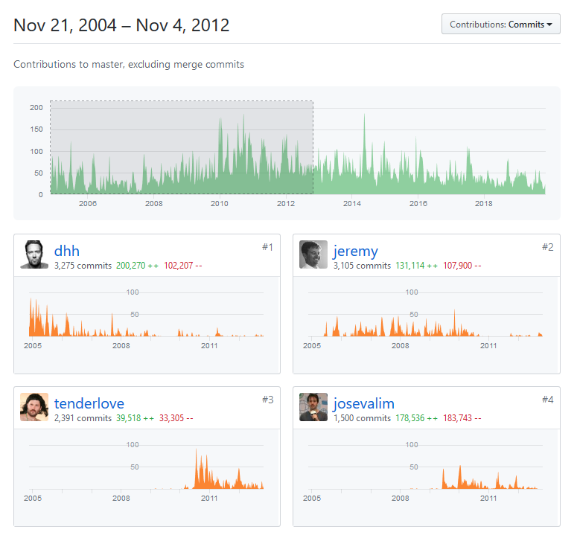

*This is the GitHub “repo” for Ruby on Rails, the free technology that runs apps like Basecamp, Airbnb, and Shopify. GitHub empowers programmers to work together, keep each other honest, and manage each other. Get familiar with how open-source works. It’s a tell-tale sign for the openness, responsibility, and immense value of all work cultures coming in the Internet Age. You should be happy! Once you experience how easy, effective, and powerful mass-collaboration is, it makes work much better. And the best part, no garbage meetings or professional delegators are needed.*

## The Setup to our Story — Making Techvolution and Player Gods

The middle-class has to step up and upgrade our way of life to the Internet Age. We must grab hold of the levers of power the open-source community has made for us and push the era of mass-collaboration forward. If we don’t, we’ll keep suffering the pains of a degenerating society. Stepping up means Main Street stops watching phantom communists and fascists on television. Instead, regular people must believe in a new philosophy that makes them player gods who take control and responsibility for their culture.

The biggest roadblock to the Internet Age is Darth Blockbuster, the self-entitled holdover from the Industrial Age. He antagonizes the future by writing rules to keep his Industrial Age tools, and himself, in power. These rules are like a Death Star. They concentrate the legal departments, HR reps, corporate lobbyists of a bygone age, to keep Main Street away from a happier life inside the era of mass-collaboration. Therefore, before our civilization can evolve, we need to defeat Darth Blockbuster and his Death Star.

And that’s the setup to the story of your life. Will you become a player god and fight our antagonists? Will you fight to control our society’s levers of power like timesheets, health statistics, and power generation? This fight is the real game of every civilization, either plays or dies. It’s not at all dramatic to say this; the fate of your children, nation, and civilization is on your shoulders.

I’ll explain the philosophy you need to win, but whether or not you decide to become a player god in the game, is up to you. Once you make up your mind, the journey to win the game starts below.

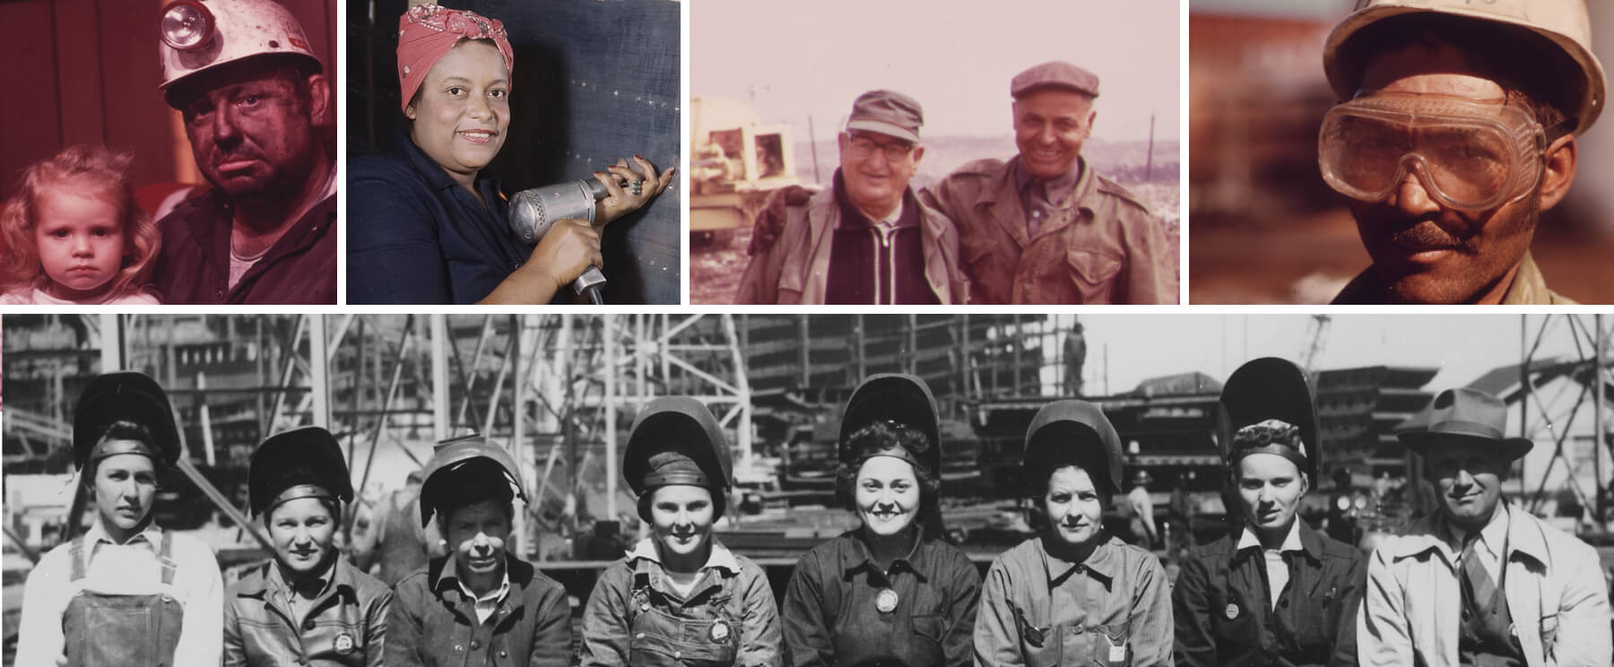

*Lots of player gods have come before us. They did their job in the era of mass-production. Now it’s our time.*

## Cast of Ideas and Characters

Before we make you a player god, here are a few terms that will put us all on the same page:

===

**Player god**: Imagine a person playing a computer “civilization building” game with our society. They would hold all the levers of power and thus decide where to put roads, what food to grow, or when houses get solar panels. Of course, there is no such deity. In reality, it’s the choices of individuals that decide what the community does. However, only when a person takes responsibility for their actions, do they become player gods who “play the game” of civilization.

**Philosophy**: The largely unspoken ideals that tell individuals what’s right and wrong, good and bad, in science, art, morals, politics, and economics. Philosophy is supposed to unite individuals to see the big picture; that everyone’s choices matter, because everyone is a player god.

**Ruling philosophy**: A civilization’s chosen philosophy. One that all factions/ideologies agree on. Examples include the “Divine Rights of Kings,” derived from Christian theology and used in royalist Europe; “Marxist-Leninism” of the Soviet Union; and the combination of “Right/Left” philosophies of the Western world today. The ruling philosophy is supposed to help society win the game of civilization.

**Happiness**: The test of how well the ruling philosophy is doing its job. Spending quality time with family, having good friends, working a steady job, being in good physical and mental health, looking forward to the future. These are all signs of (genuine) happiness.

**Rulebook**: The written and unwritten social, workplace, and legal rules that govern everyday life. People write the rulebook by interpreting the ruling philosophy. Some examples are city by-laws, workplace seniority rules, and environmental regulations.

**Technology**: A catchall term for things we make tools from, like concrete, lumber, nails, shingles, insulation, and bricks.

**Tool**: A catchall term for things we create with technology to solve a problem, like guns to kill bad guys, books to record and pass on knowledge, and houses to shelter in. We use tools to evolve.

**Levers of Power**: The most powerful tools; the ones that control society. In Civilization games, these are the buttons, toggles, and sliders players use to play. In reality, levers of power are the tools that power, educate, inform, feed, and transport resources in our society.

**Frontline**: The point of contact between a tool and the problem. Nurses giving vaccines, cleaners cleaning a city bus, and soldiers on the battlefield are all examples of frontline settings. People on the frontline work on Main Street with jobs that solve specific problems with a proven skillset. Frontline workers physically hold the levers of power, but don’t always control them—they will, once the era of mass-collaboration starts.

**Hierarchy**: A power structure that manages every lever of power’s use by society. Kings and queens with the keys to the castle, or the corporate ladder at Blockbuster controlling DVD rentals, are examples of past hierarchies. As hierarchies grow, they get more detached from the frontline and start forming gates to protect their tool being replaced as a lever of power. People in the regime give themselves titles like prince and executive, baron, and supervisor to mark their position—and, in a sense, their territory and “rights” in the power structure.

**The Game of Civilization**: The invention of technology, and the creation of tools, to overcome frontline problems. Civilization develops new technology in ages. As new technology makes new tools, they create new levers of power which inventors use to open the gates—and topple the hierarchies—of the prior era.

**Protagonists**: People who invent, spread, and use new technology for the greater good. Usually close to the problems on the frontline, they individually struggle. Still, their continued self-sacrifice slowly improves life on Earth. I call them this world’s Jedi knights. We call their leaders trailblazers who often skirt the rules. Galileo, Nikola Tesla, Michael Faraday, Jay Last, Grace Hopper, Michael S. Hart, Dennis Ritchie, Bill Gates, Steve Jobs, Linus Torvalds, Salman Khan, Jeff Bezos, and Elon Musk are among their number.

**Antagonists**: People who selfishly defend their wealth, power, and prestige atop a hierarchy. Antagonists manage companies or institutions based on dated technologies and think that working on the frontline is beneath them. They work to control society’s rulebook, so they can prevent protagonists’ new tools becoming new levers of power. We don’t often individually identify them. I coined the term “Darth Blockbuster” so we can.

**Extras**: Everybody in the middle of a battle between antagonists and protagonists. Because they’re unattached to either side, extras can pick winners and losers. Usually, extras are in the middle class, not so poor as to be desperate, but not so powerful that they want to keep the world the same. Sadly, extras don’t realize their power and often refuse to accept they’re living inside a game of civilization. When they do, they become player gods. If they don’t, the game of civilization turns into a story they merely watch. Extras blame phantom ideologies for their real-life problems.

**The Death Star**: The rulebook when it’s controlled by Darth Blockbuster. Today it exists inside many regulations, agreements, manuals, contracts, and laws that prevent new levers of power from reaching Main Street. The Death Star is currently busy trying to keep the Industrial Age alive.

**Techvolution**: A new philosophy empowering seamless human technological evolution by ridding Darth Blockbuster of his power, by giving player gods the right and duty to decide when society should upgrade our tools.

**The Life Star**: A rulebook based on Techvolution that’s governed by human technological adaption and natural selection. It makes sure humanity never again creates antagonists who stall our upgrade to the next technological age.

**Plot**: Getting the extras to step up, grab hold of society’s new digital levers of power, and become player gods who replace their ruling philosophy with Techvolution and thereby establish the era of mass-collaboration inside the Internet Age.

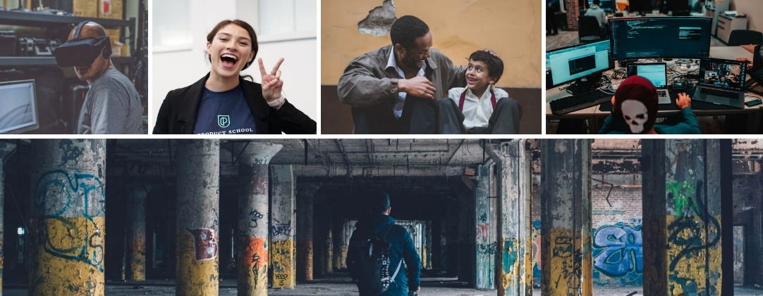

*Our civilizations have always had problems. It’s up to regular people to use new tools to solve them. It’s simply our turn to today. Let’s get started.*

# ACT ONE

## The Beginning

It all started with a door in my face. And then, actually, a few more. I was either being too stubborn or too hopeful. Either way, I eventually learned my lesson. I was selling a web app that those in upper management were never going to buy.

Before you wonder, it wasn’t a matter of price, because there was no price. It wasn’t a question of competition. None of that either. And I can promise it worked, because I had spent years in a cubicle doing the frontline job it serviced. After years of thinking about political and economic theory in the Internet Age, I’d written a book (Starting Starfleet) about some untapped possibilities of new tech like smartwatch apps, bio-monitors, and bitcoin. I only made this simple web app (using open-source technologies) validate some of my ideas.